



**信息学院软件工程系**

**《JAVA程序设计》实验报告**

实验四

**姓名：庾晓萍**

**学号：20420192201952**

**学院：信息学院**

**专业：软件工程**

**完成时间：2022/3/18**

1. **实验目的及要求**

（一）实验目的

1、熟悉数组的使用

2、熟悉简单的JavaFX图形界面

1. 实验要求

1、下周前五前将工程文档和实验报告打包上传到FTP

1. **实验题目及实现过程**

一、基本题目：

题目1：

(Game of Craps) Write an application that runs 1,000,000 games of craps and answers the following questions:

(a)  How many games are won on the first roll, second roll, ..., twentieth roll and after the twentieth roll?

(b)  How many games are lost on the first roll, second roll, ..., twentieth roll and after the twentieth roll?

(c)  What are the chances of winning at craps? [Note: You should discover that craps is one of the fairest casino games. What do you suppose this means?]

(d)  What is the average length of a game of craps?

(e)  Do the chances of winning improve with the length of the game?

二、Craps的定义

Craps is a game played with a pair of dice. In the game of craps, the shooter (the player with the dice) rolls a pair of dice and the number of spots showing on the two upward faces are added up. If the opening roll (called the ‘coming out roll’) is a 7 or 11, the shooter wins the game. If the opening roll results in a 2 (snake eyes), 3 or 12 (box cars), the shooter loses, otherwise known as ‘crapping out’. If the shooter rolls a 4, 5, 6, 8, 9 or 10 on the opening roll, then he or she must roll the same number before rolling a 7 to win the game. For example, if the shooter rolls a 6 on the come out roll, a 10 on the second roll and a 7 on the third roll, the shooter loses since he rolled a 7 before rolling another 6. If, however, he rolled a 6 on the third roll, he wins the game.

1. **实验环境**

操作系统：Windows 10；

IDE：Eclipse Java 2018-12

编程语言：Java；

1. **实现过程**
2. 设计类

设计了名为GameCraps 的类，其中包括main方法，用来实现用户输入输出与方法调用。用户输入一个整数代表游戏进行的轮数。main函数将调用initialize方法进行初始化，即将储存各种数据的变量置零，再在循环中调用playCraps方法来完成每一局的游戏，而在playCraps方法中，每次扔掷骰子将通过rollDice方法来完成。

1. 调用关系

调用关系如下图，即main方法可以对initialize方法和playCraps方法进行调 playCraps方法可以对rollDice方法进行调用。

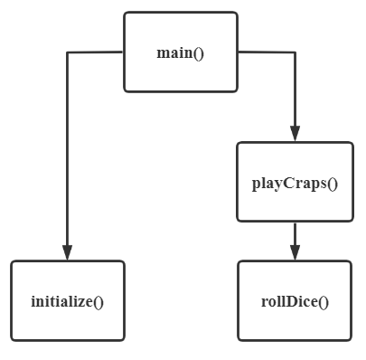

1. 问题思考

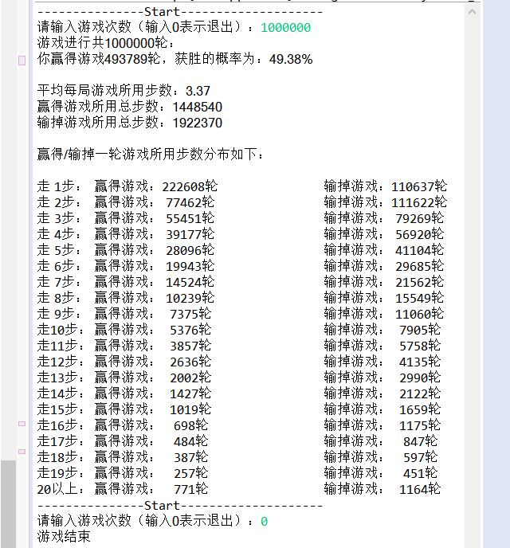

1. How many games are won on the first roll, second roll, ..., twentieth roll and after the twentieth roll?

由游戏运行结果可知，进行1000000轮游戏，其中走一步赢得游戏的局数为222608轮、走两步赢得游戏的轮数为77462轮……（具体见上图）

1. How many games are lost on the first roll, second roll, ..., twentieth roll and after the twentieth roll?

由游戏运行结果可知，进行1000000轮游戏，其中走一步输掉游戏的局数为110637轮、走两步赢得游戏的轮数为111622轮……（具体见上图）

1. What are the chances of winning at craps? [Note: You should discover that craps is one of the fairest casino games. What do you suppose this means?]

由游戏运行结果可知，进行1000000轮游戏，计算得到游戏获胜的概率为49.38%，接近0.5，可以说craps是相对公平的游戏，即获胜概率和失败概率几乎相等。

1. What is the average length of a game of craps?

由游戏运行结果可知，进行1000000轮游戏，平均每轮游戏的步数为3.37，即平均三步多可以完成一局游戏。

(e)  Do the chances of winning improve with the length of the game?

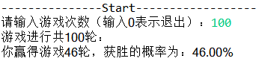

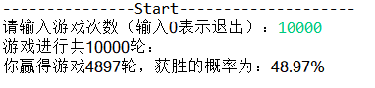

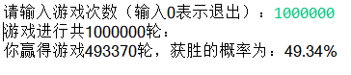

运行代码，发现随着游戏局数增多，获胜概率确实增加了。

1. **过程截图**
2. 全屏截图

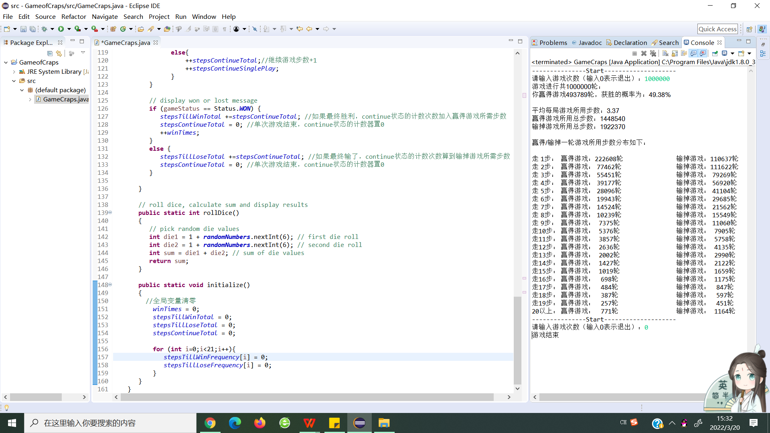

1. 运行结果
2. 用户输入1000000表示进行游戏1000000局，输出游戏进行总轮数、玩家赢得游戏局数、玩家获胜概率、平均每局游戏所用步数、赢得游戏所用总步数、输掉游戏所用总步数，最后以表格形式输出赢得/输掉一轮游戏所用步数的分布。



题目2：

(Airline Reservations System) A small airline has just purchased a computer for its new automated reservations system. You’ve been asked to develop the new system. You’re to write an application to assign seats on each flight of the airline’s only plane (capacity: 10 seats).

Your application should display the following alternatives: Please type 1 for First Class and Please type 2 for Economy. If the user types 1, your application should assign a seat in the first- class section (seats 1–5). If the user types 2, your application should assign a seat in the economy section (seats 6–10). Your application should then display a boarding pass indicating the person’s seat number and whether it’s in the first-class or economy section of the plane.

Use a one-dimensional array of primitive type boolean to represent the seating chart of the plane. Initialize all the elements of the array to false to indicate that all the seats are empty. As each seat is assigned, set the corresponding element of the array to true to indicate that the seat is no longer available.

Your application should never assign a seat that has already been assigned. When the economy section is full, your application should ask the person if it’s acceptable to be placed in the first-class section (and vice versa). If yes, make the appropriate seat assignment. If no, display the message "Next flight leaves in 3 hours."

**（一） 实验环境**

操作系统：Windows 10；

IDE：Eclipse Java 2018-12

编程语言：Java；

**（二） 实现过程**

（1）设计类

设计了用于投掷航空公司预订系统的AirlineReservationsSystem类，包括main方法，用来显示选择菜单，读取用户输入，并调用相关方法。键入1为头等舱，键入2为经济舱。如果用户输入1，程序在座位1-5分配一个座位。如果用户输入2，程序在座位6-10分配一个座位。其中displayMessage用于输出登机卡信息，显示乘客的座位号码，以及在头等舱还是经济舱。checkAvailable用于检查可以使用的座位。使用原始类型布尔值的一维数组来表示平面的座位图。将数组中的所有元素初始化为false，以表示所有座位都是空的。当分配每个座位时，将数组的相应元素设置为true，以表明该座位不再可用。

（2）调用关系

调用关系如下图，即main方法可以对displayMessage方法和checkAvailable 方法进行调用。

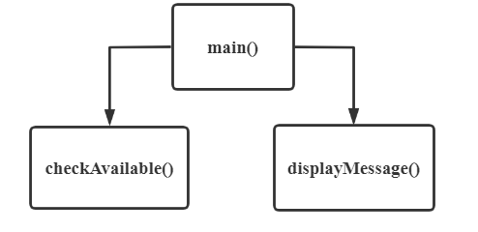

**（三） 过程截图**

（1）全屏截图

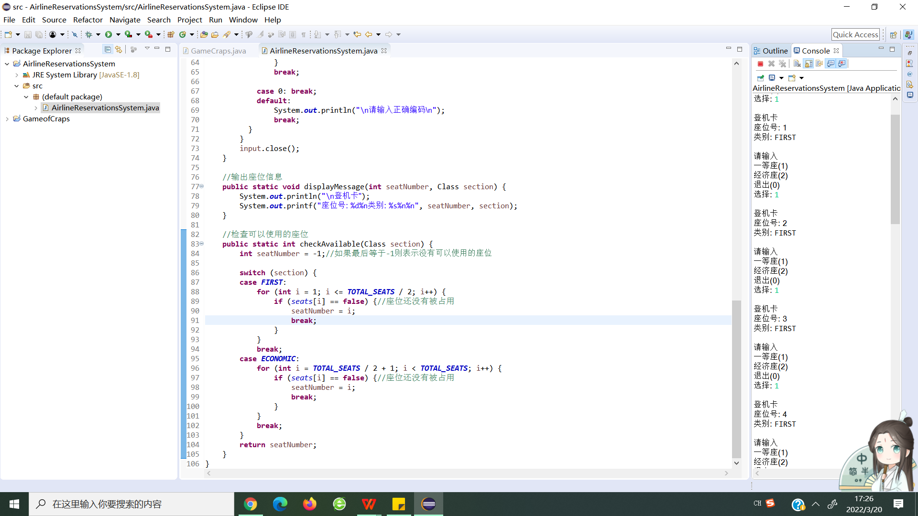

（2）运行结果

1. 用户选择座位类型，输出登机卡

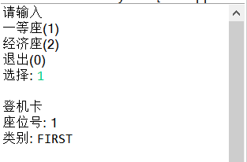

2. 某类座位已满时，询问是否要更换其他种类的座位

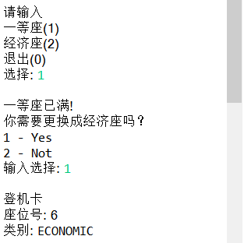

3. 没有更多座位时，输出航班已满

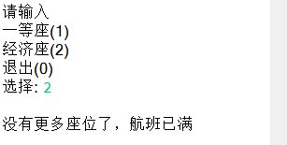

题目3：

(Turtle Graphics) The Logo language made the concept of turtle graphics famous. Imagine a mechanical turtle that walks around the room under the control of a Java application. The turtle holds a pen in one of two positions, up or down. While the pen is down, the turtle traces out shapes as it moves, and while the pen is up, the turtle moves about freely without writing anything. In this problem, you’ll simulate the operation of the turtle and create a computerized sketchpad.

Use a 20-by-20 array floor that’s initialized to zeros. Read commands from an array that contains them. Keep track of the current position of the turtle at all times and whether the pen is currently up or down. Assume that the turtle always starts at position (0, 0) of the floor with its pen up. The set of turtle commands your application must process are shown in Fig. 7.29.

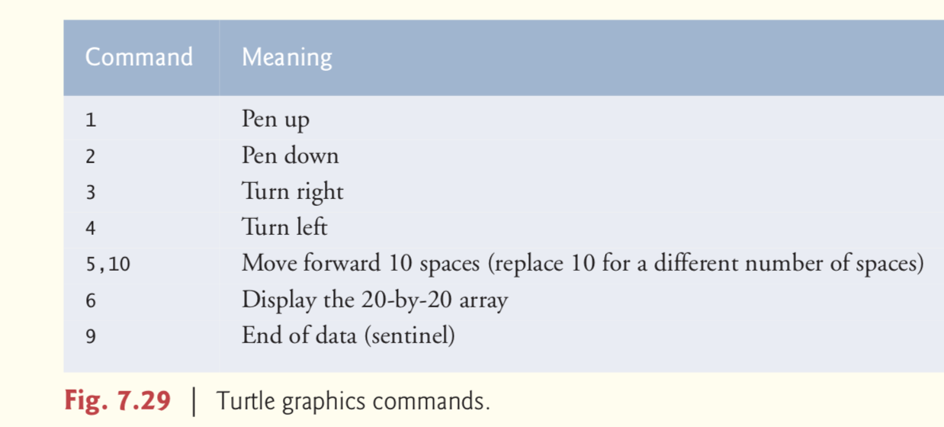

Suppose that the turtle is somewhere near the center of the floor. The following “program” would draw and display a 12-by-12 square, leaving the pen in the up position:

2

5,12

3

5,12

3

5,12

3

5,12

1

6

9

As the turtle moves with the pen down, set the appropriate elements of array floor to 1s. When the 6 command (display the array) is given, wherever there’s a 1 in the array, display an asterisk or any character you choose. Wherever there’s a 0, display a blank.

Write an application to implement the turtle graphics capabilities discussed here. Write several turtle graphics programs to draw interesting shapes. Add other commands to increase the power of your turtle graphics language.

**（一） 实验环境**

操作系统：Windows 10；

IDE：Eclipse Java 2018-12

编程语言：Java；

**（二） 实现过程**

（1）设计类

① 设计了用于绘制海龟图形的TurtleGraphics类。构造函数可以调用reset方法，将网格和坐标重置为默认值。setpen方法可以更改画笔图案。penUp和penDown可以设置画笔是否处于绘制状态。turnLeft、turnRight可以改变画笔所朝的方向。getLocationDirection可以打印画笔所在位置与画笔的方向。forward可以使画笔在drawDir方向移动n步。showGrid可以打印最终绘制的图形。printMenu可以打印命令菜单。

② 设计了用于完成一次绘图的Drawer类。Drawer类中new了一个TurtleGraphics对象，在main方法调用该对象的各种方法实现绘图。

（2）调用关系

调用关系如下图，即Drawer类的main方法可以对TurtleGraphics类中的 reset、setpen、penUp、penDown、turnLeft、turnRight、getLocationDirection、 forward、showGrid、showGrid方法进行调用。

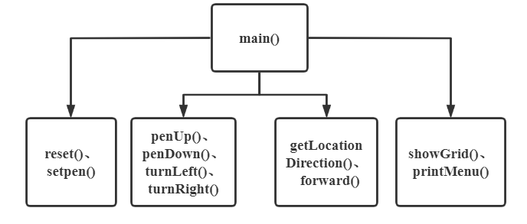

**（三） 过程截图**

（1）全屏截图

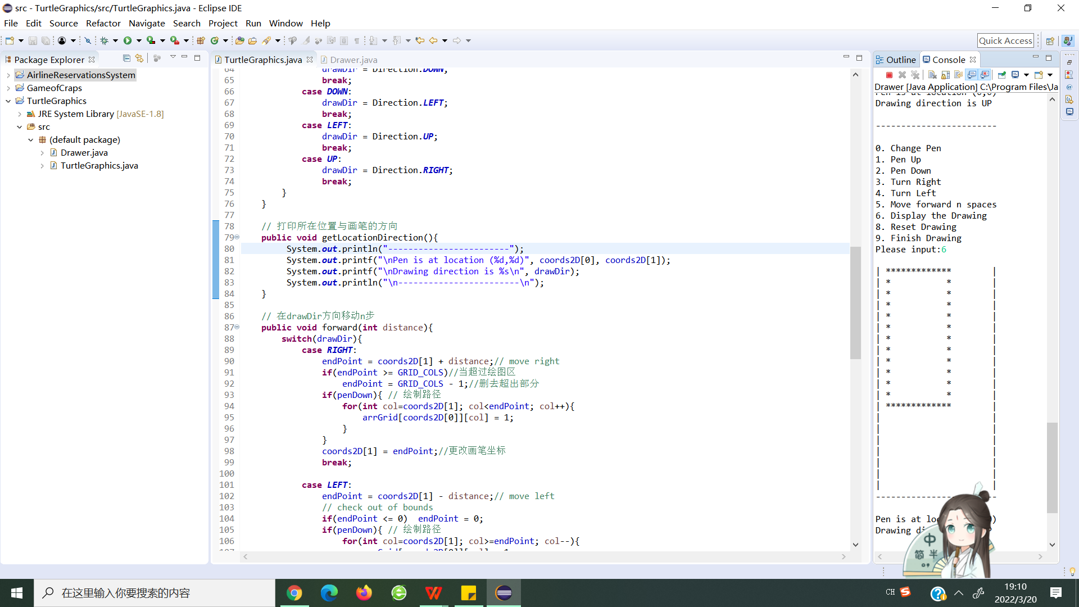

（2）运行结果

1. 提示画笔的位置，以及画笔的位置，用户选择操作2，即落下画笔。

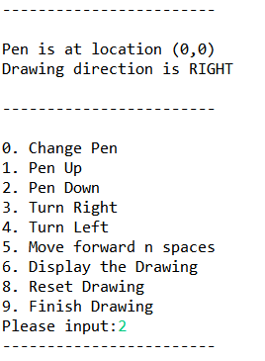

2. 输入三次命令5 12 3，代表连续绘制3组*（12个），绘制后右转。再输 入6得到打印图形。

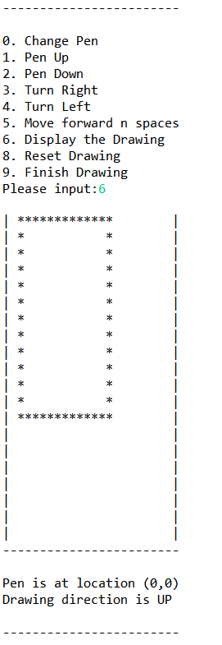

3. 添加了命令可以更改画图案

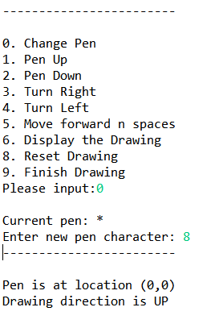

题目4：

(Enhancing Class Time2) Modify class Time2 to include a tick method that increments the time stored in a Time2 object by one second. Provide method incrementMinute to increment the minute by one and method incrementHour to increment the hour by one. Write a program that tests the tick method, the incrementMinute method and the incrementHour method to ensure that they work correctly. Be sure to test the following cases:

(a)  incrementing into the next minute,

(b)  incrementing into the next hour and

(c)  incrementing into the next day (i.e., 11:59:59 PM to 12:00:00 AM).

**（一） 实验环境**

操作系统：Windows 10；

IDE：Eclipse Java 2018-12

编程语言：Java；

**（二） 实现过程**

（1）设计类

① 设计了用于存储和修改时间的Time2Enhanced类。构造函数可以通过传入不同数量的参数来将每个实例变量进行不同的初始化操作。setTime方法可以调用setHour、setMinute、setSecond方法来检验并设置小时、分钟、秒。incrementMinute、incrementHour方法可以用来增加小时和分钟的时间。toUniversalString和toString方法可以得到通用时间和标准时间。getMinute、 getSecond、getHour方法可以得到当前时间的分钟、秒和小时。

② 设计了用于完成时间滴答测试的Test类。Drawer类中new Time2Enhanced对象，在main方法调用Time2Enhanced的构造函数初始化、调用toUniversalString方法转化成通用时间，调用toString方法转换为标准时间。调用incrementMinute方法实现分钟的增加，调用incrementHour方法实现小时的增加。

（2）调用关系

调用关系如下图，即Test类的main方法可以对Time2Enhanced类中的构造 函数、toUniversalString和toString方法、incrementMinute、incrementHour 方法进行调用。构造函数可以对Time2Enhanced类中setHour、setMinute、 setSecond方法进行调用。toUniversalString和toString方法可以调用 Time2Enhanced类中的getMinute、getSecond、getHour方法。

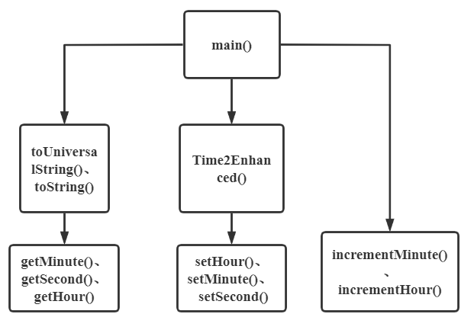

**（三） 过程截图**

（1）全屏截图

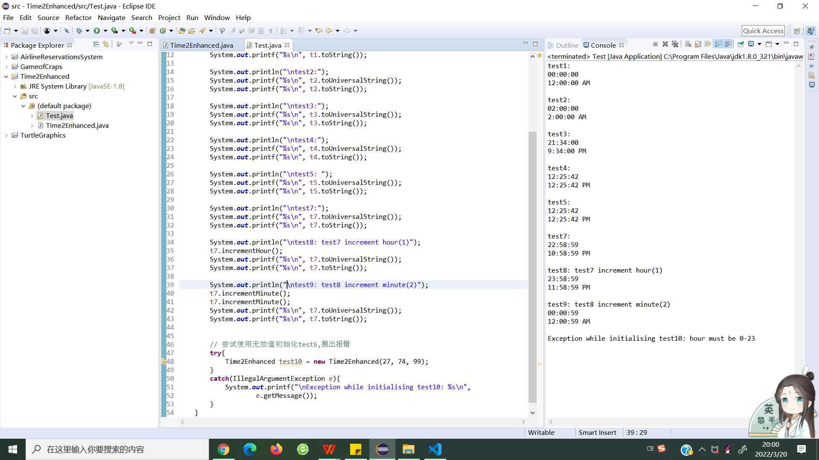

（2）运行结果

1. test1是所有参数设为默认值的结果，test2是小时是自定义，其他参数设置 为默认值的结果，test3是小时和分钟自定义，秒设置为默认值的结果。test4 是小时、分钟、秒都是自定义的结果。test5是由test4指定得到。

2. test8成功测试了增加时间到接下来的一个小时（即晚上10:58:59至晚上11： 58：59）

3. test9成功测试了增加时间到第二天（即晚上11：58：59至上午12：00： 59）。

4. 尝试使用无效值初始化test6，成功抛出报错“hour must be 0-23”

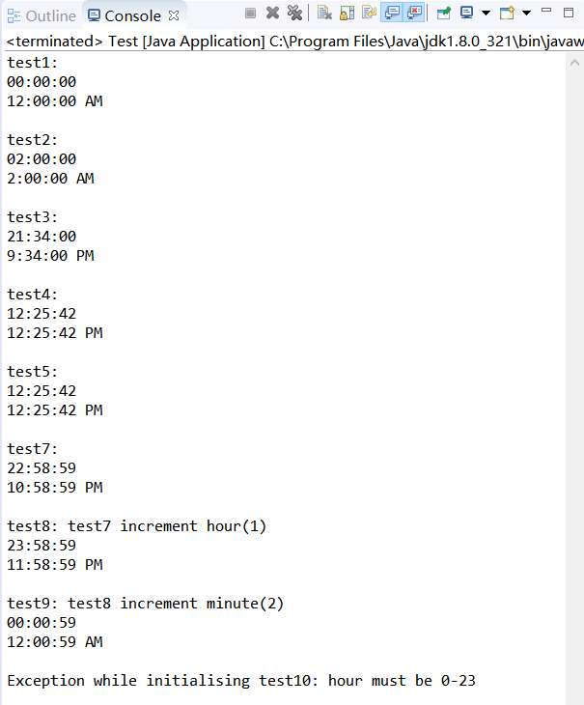

题目5：

(Addition App) Create a JavaFX version of the addition program. Use two TextFields to receive the user’s input and a Button to initiate the calculation. Display the results in a Label. Since TextField method getText returns a String, you must convert the String the user enters to an int for use in calculations. Recall that the static method parseInt of class Integer takes a String argument representing an integer and returns the value as an int.

**（一） 实验环境**

操作系统：Windows 10；

IDE：Eclipse Java 2018-12

编程语言：Java；

**（二） 实现过程**

（1）设计类

① AdditionApp类中，继承了Application抽象类并重写了start()方法，在该方法中，Stage就是JavaFX工具中用来表示整个图形工具界面窗口的类，在该类中需要加入一个Scene（场景）来进行填充，而所有的组件、元素都是构建在Scene中的。另外，在JavaFX 8中支持代码与布局和样式分离，所以在文件中通过FXMLLoader的load()方法引入了一个外联的AdditionApp.fxml文件，在此fxml文件中就可以专心编写图形界面布局和组件相关功能。

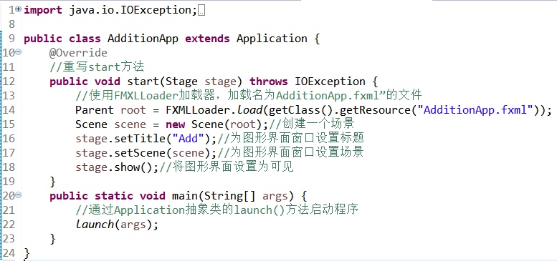

② AdditionApp.fxml文件中设置了画布的宽度为250，字体大小为18size，控制文件为AdditionAppControlloer.java。同时设置了两个TextField，一个的id是number1TextField，显示文字为Number 1。另一个的id是number2TextField，显示文字为Number 2。设置了一个Button，显示文本是Calculate。

③ 在AdditionAppController类中，通过calculateSumButtonPressed方法来计算输入的两个数的相加结果。通过getNumber方法来获取用户输入。使用TextField对象的getText方法来获取文本内容，调用String类中的trim方法来减少用户输入的多余空格，用Integer.parseInt将String型对象转换为一个整型对象。同时，当捕获到错误时，将提示用户应该输入一个整数。

（2）调用关系

调用关系如下图，即main方法可以通过加载AdditionApp.fxml来对 AdditionAppController类中的方法进行调用。AdditionAppController类中，通过calculateSumButtonPressed方法来计算输入的两个数的相加结果。通过getNumber方法来获取用户输入。

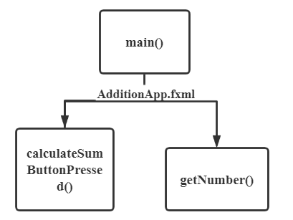

**（三） 过程截图**

（1）全屏截图

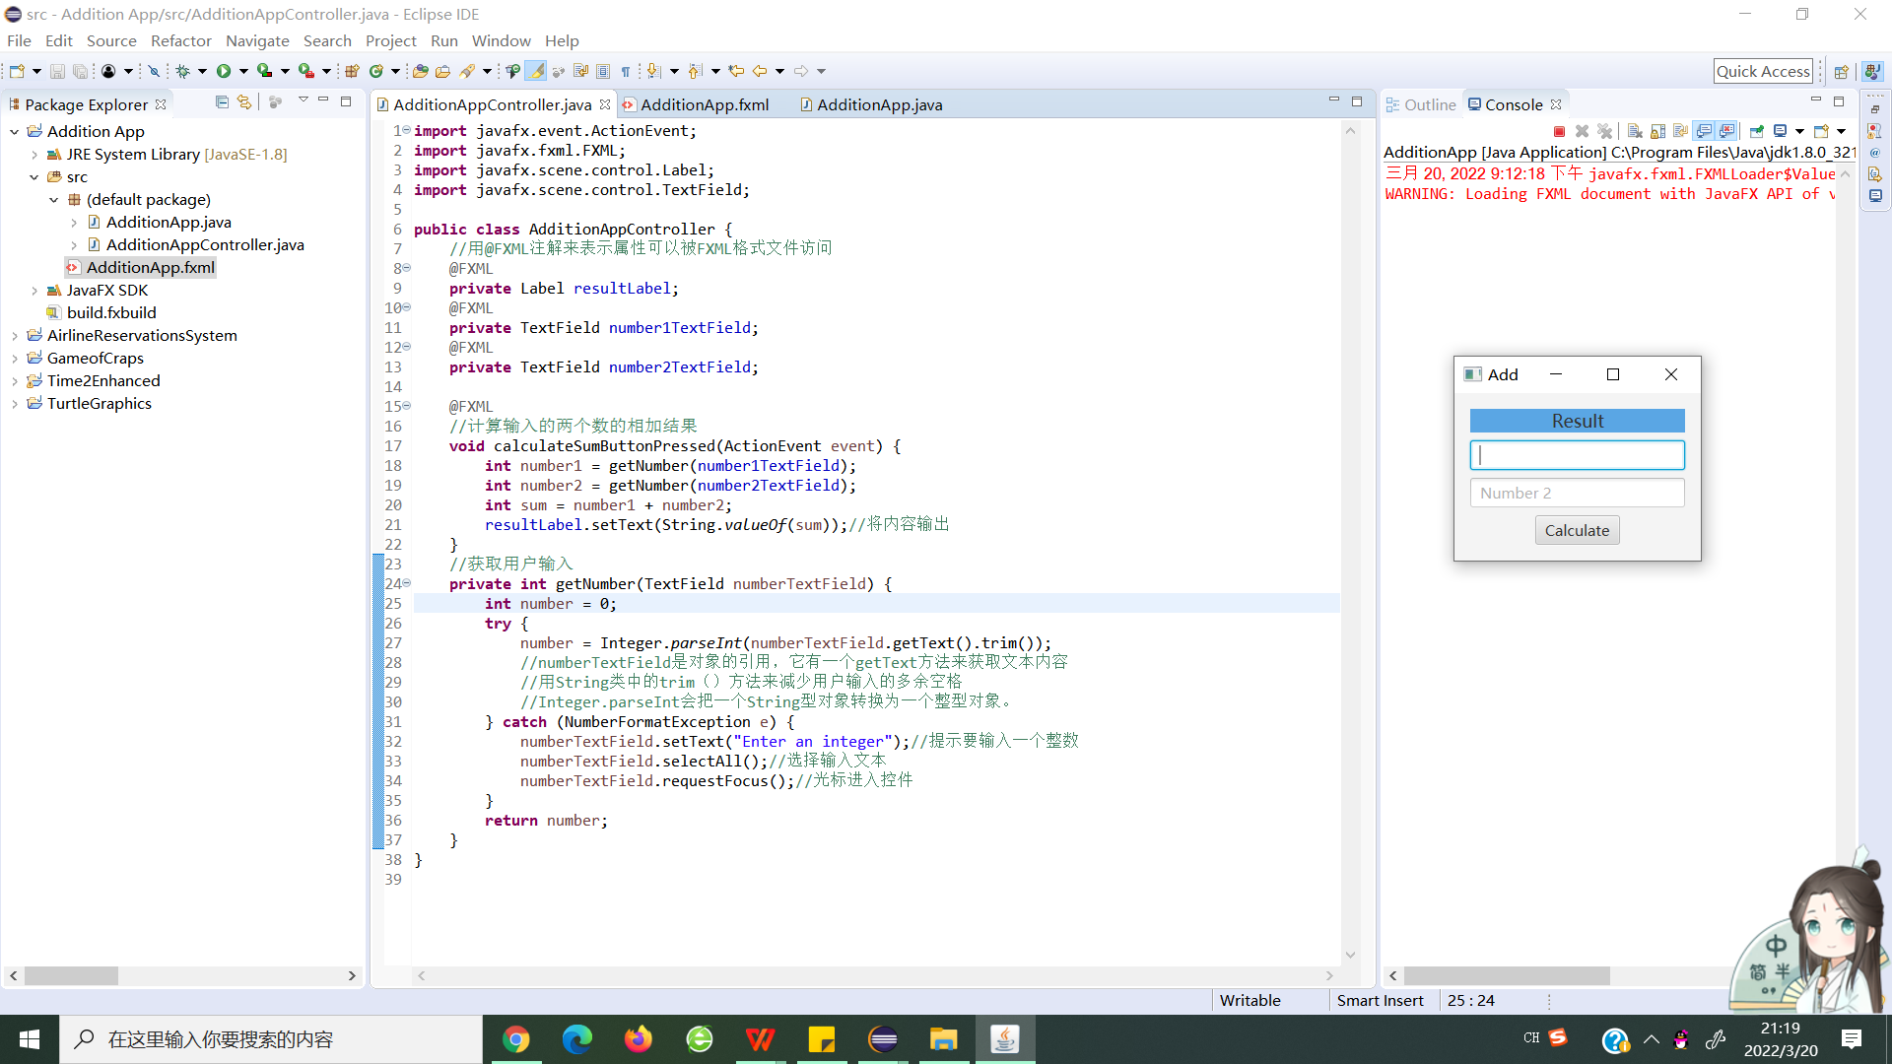

（2）运行结果

1. 输入数字5和10计算出正确结果。

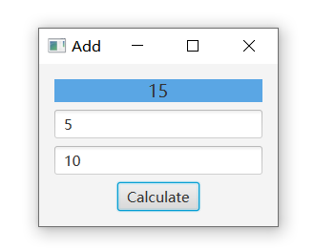

2. 当输入不是数字时，清除输入并输出错误。

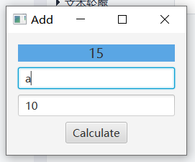

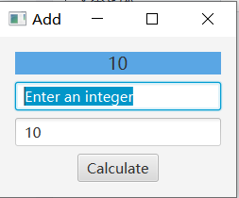

扩展题目：

(7.30 Card Shuffling and Dealing) Modify Fig. 7.11 to deal a five-card poker hand. Then modify class DeckOfCards of Fig. 7.10 to include methods that determine whether a hand contains

I.a pair（一对 5张中2张的数字一样，另外3张不相同）

II.two pairs（两对 4张中两两数字一样，余下1张不同）

III.three of a kind(e.g., three jacks 三条 5张中3张的数字一样)

IV.four of a kind(e.g.,four aces四条)

V.a flush(i.e.,all five cards of the same suit,同花 五张花色一样)

VI.a straight(i.e.,five cards of consecutive face values，顺子 五张数字相连)

VII.a full house(i.e., two cards of one face value and three cards of another face value 葫芦3张数字一样，另外2张数字一样)

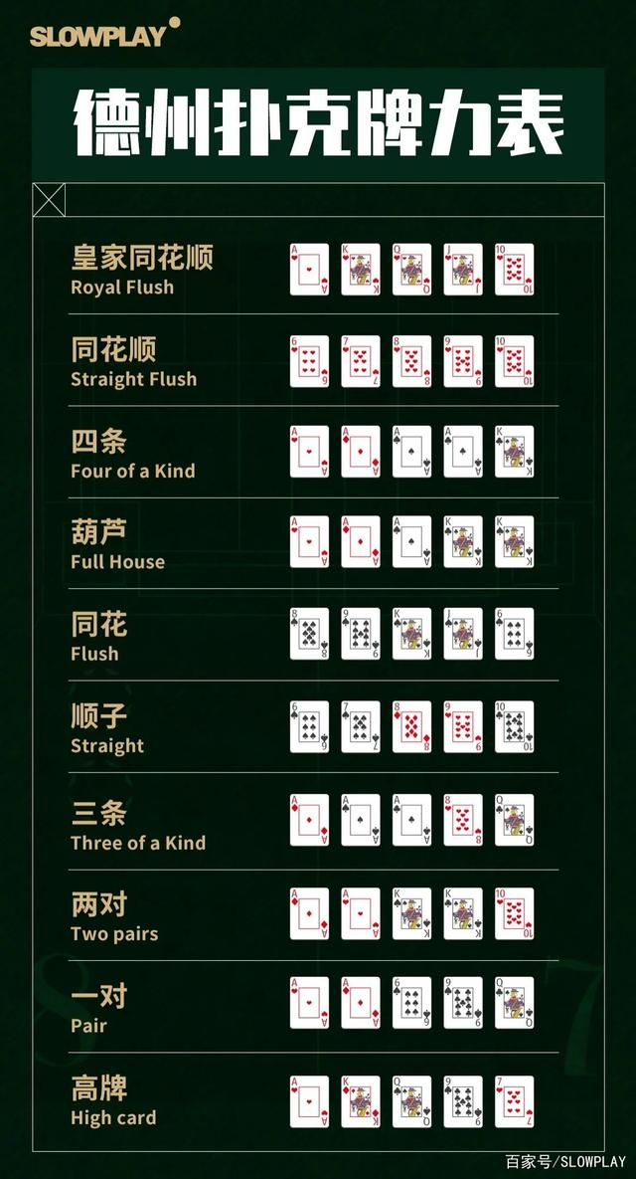

2. (7.31 Card Shuffling and Dealing) Use the methods developed in Exercise 7.30 to write an application that deals two five-card poker hands, evaluates each hand and determines which is better.

3. (7.32 Project: Card Shuffling and Dealing) Modify the application developed in Exercise 7.31 so that it can simulate the dealer. The dealer’s five-card hand is dealt “face down,” so the player cannot see it. The application should then evaluate the dealer’s hand, and, based on the quality of the hand, the dealer should draw one, two or three more cards to replace the corresponding number of unneeded cards in the original hand. The application should then reevaluate the dealer’s hand. [Caution: This is a difficult problem!]

4. (Project: Card Shuffling and Dealing) Modify the application developed in Exercise 7.32 so that it can handle the dealer’s hand automatically, but the player is allowed to decide which cards of the player’s hand to replace. The application should then evaluate both hands and determine who wins. Now use this new application to play 20 games against the computer. Who wins more games, you or the computer? Have a friend play 20 games against the computer. Who wins more games? Based on the results of these games, refine your poker-playing application. (This, too, is a difficult problem.) Play 20 more games. Does your modified application play a better game?

5.(Project: Card Shuffling and Dealing) Modify the application of Figs. 7.9 –7.11 to use Face and Suit enum types to represent the faces and suits of the cards.

Declare each of these enum types as a public type in its own source-code file. Each Card should have a Face and a Suit instance variable. These should be initialized by the Card constructor. In class DeckOfCards, create an array of Faces that’s initialized with the names of the constants in the Face enum type and an array of Suits that’s initialized with the names of the constants in the Suit enum type. [Note: When you output an enum constant as a String, the name of the constant is displayed.]

**（一） 实验环境**

操作系统：Windows 10；

IDE：Eclipse Java 2018-12

编程语言：Java；

**（二） 实现过程**

（1）设计类

① Card 类代表一张扑克牌，通过两参数的构造函数初始化卡片的面和花色。同时有getFace、getSuit方法返回卡牌的花色和大小。toString方法返回 Card 的字符串表示形式

② DeckOfCards 类表示一副扑克牌，调用构造函数填充纸牌。shuffe方法用于洗牌，drawCards方法用于发牌。

③ Rule类储存规则，相当于裁判。compareTwoPlayers方法用于比较两个牌手不同的得分。将调用isPair、isTwoPairs、isTOAK、isFOAK、isFlush、isStraight、isFullHouse方法判断是否是一对、两对、三条、四条、同花、顺子、葫芦。

④ Player类表示玩家，通过change方法进行换牌，通过autoChange方法进行自动换牌

⑤ Test1类可以实现随机抽牌，判断大小等级。Test2类可以建立两个玩家对战，并输出胜负结果。Test3类可以实现玩家与电脑对战，并拥有玩家选择换牌的功能。

**（三） 过程截图**

（1）全屏截图

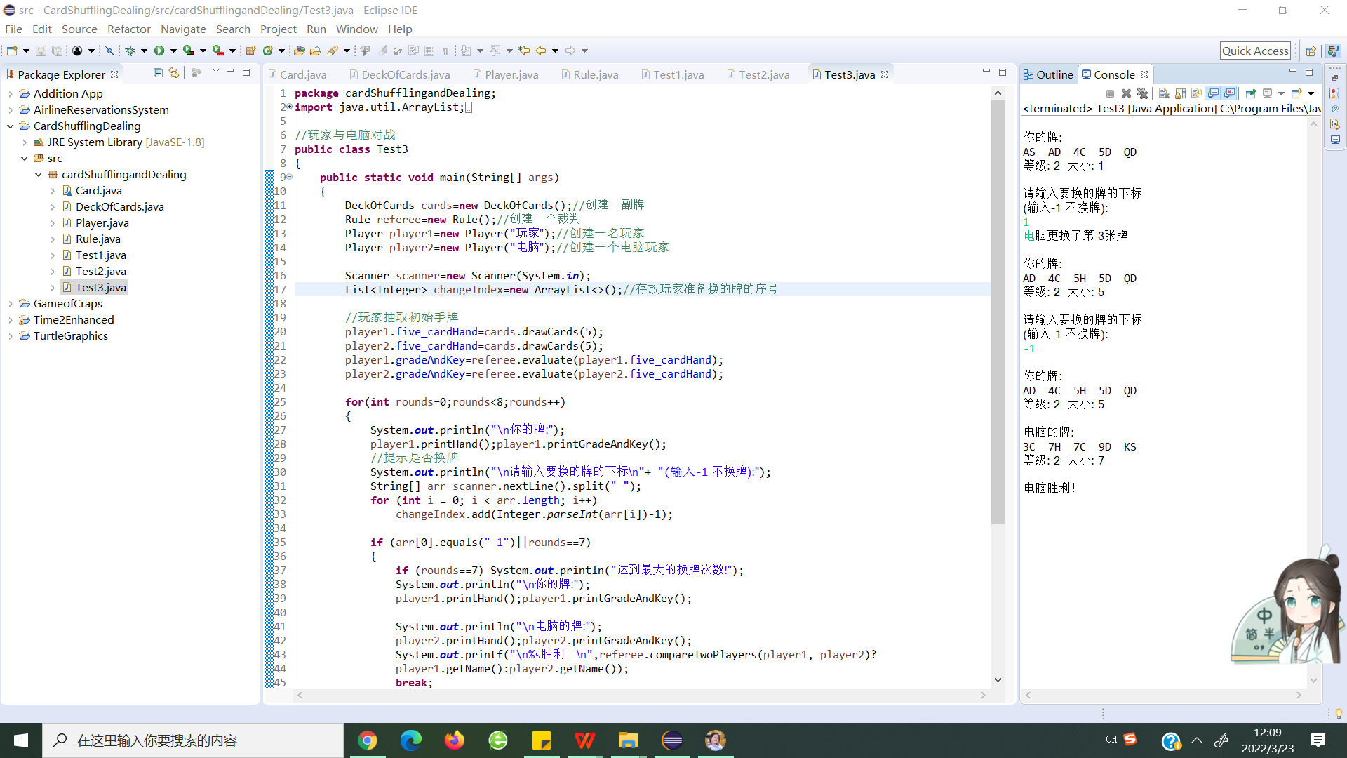

（2）运行结果

（1）Test1中实现随机抽牌，判断并判断抽到的牌的大小等级。

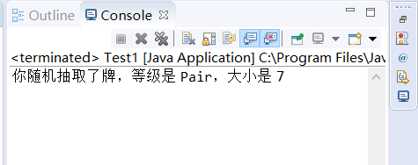

（2）Test2类可以建立两个玩家对战，并输出胜负结果。

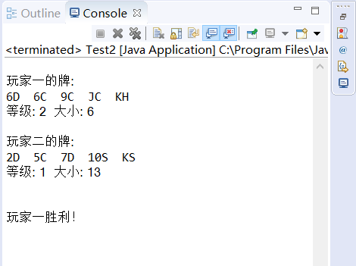

（3）Test3实现玩家与电脑对战，并且玩家可以选择换牌。

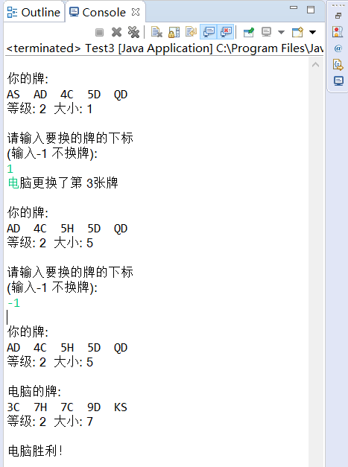

**三、实验总结与心得记录**

在本次实验过程中，我练习了控制结构，熟悉了java的语法，熟悉了java类 的定义，实例化和调用。我也熟悉了简单的枚举和简单的JavaFX图形界面，体 会到了JAVA语言的优点。